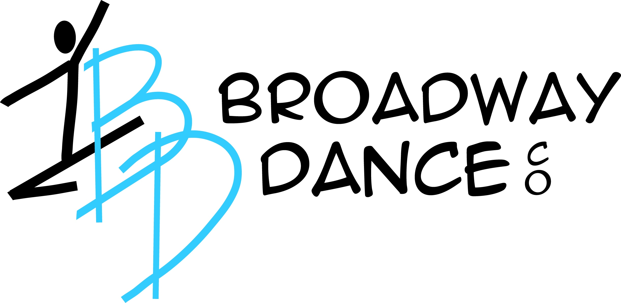
2024 Recital Packet

Dear BDC Family,

Inside this packet you will find all the information you will need for dress rehearsal as well as recital. It is a lot of information, please read it all carefully and keep this packet in a safe place for future reference.

When putting together our recital we try our best to accommodate every BDC family. We want you to have the most enjoyable experience with your dancer on their recital day. Please know the show order is final and will not be changed.

Your dancer has been working so hard this year and we want to celebrate them at recital. We have loved teaching them this year and hope they dance with us for many more years to come.

To receive a recital text remind please type @updatebdc to 81010.

I am always available for questions. Please feel free to contact me at
248-693-2555 or michelle@broadwaydanceco.com.

Thank you,

Michelle Larnard
Owner/Artistic Director
BDC 12th Annual Dance Recital
Lake Orion High School Performing Arts
495 E Scripps Road
Lake Orion MI 48360

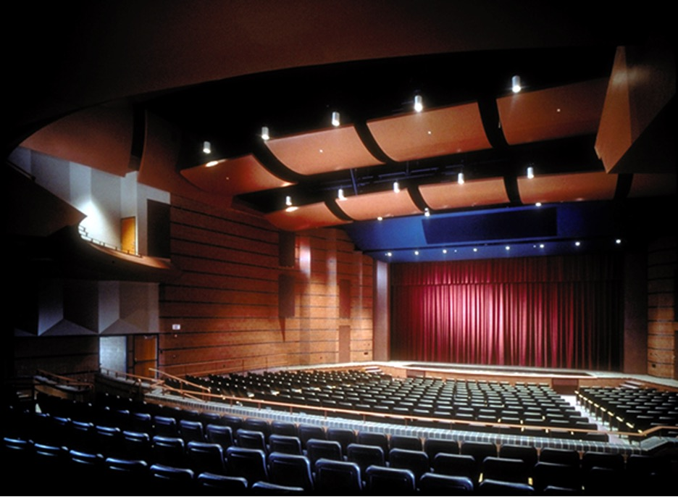

Dress rehearsal (MANDATORY)
Saturday, June 1st
9:30AM-5:30PM (see page 15 for lineup)

Show 1
Sunday, June 2nd
11:00AM-2:00PM (see page 17 for lineup)

Show 2
Sunday, June 2nd
4:00PM-7:00PM (see page 18 for lineup)
Tips for a Successful
Dress Rehearsal
and Recital

- Be organized- have all costumes steamed and ready, all head pieces, gloves, shoes, tights, etc. packed neatly. There is nothing to frazzle a dancer more than to not have all their costume parts/shoes.
- Be on time. Arrive 15-20 minutes BEFORE the show begins, get a program, find a quiet place and set up your costumes.
- Have your hair and makeup done BEFORE you arrive at the venue.
- Bring an extra pair of tights. You never know when you will get a hole, get a mark or something else happens to your tights.
- Clean your ballet shoes. Canvas shoes can be washed. Make sure to AIR DRY them because a dryer will shrink them. Leather shoes can be scrubbed with household cleaner to remove brown and black marks.
- Bring hairpins, hair spray, extra hair ties, and makeup. Hair and makeup need to be touched up throughout the performance.
- DO NOT SHARE MAKEUP. Doing this can pass too many infections.
- Stay until the end of the recital. There is a final group bow. You cannot check your child out until the end of the show.
- No flash photography or videotaping during the recital. You may take pictures and video during dress rehearsal.
- Your dancer may get nervous to be on stage, this is normal. That is why we have a dress rehearsal where they practice their dance and become confident. They will do great. Use positive words of encouragement if they are feeling uneasy.
- Do Not wear underwear under your costume!
- Cheer for everyone at recital, we show our enthusiasm through clapping!
- Dancers ages 4 and older will be checked in backstage prior to the show. No early checks out will be allowed. Dancers ages 3 and younger will sit with you in the audience.
- No jewelry or nail polish allowed on dancers
- To receive a recital text remind please type @updatebdc to 81010.

BDC Recital Q & A

- Should I wear my costume to the recital?
Yes, wear your costume, tights and street shoes to the show. Change into your dance shoes backstage. Have your hair and makeup done too.

- Can I take pictures or videos of the recital?
Pictures and videos of any kind are prohibited during the recital. It is distracting to the audience as well as unsafe to the dancers. A professional videographer will record our performances. Each family will receive a downloadable link to both shows.

- Why do we need to stay until the end of the performance?
We ask ALL dancers to be a part of our grand finale bow. Our dancers work so hard all year long and the best reward is the applause of a full audience.

- What if my dancer won’t perform on stage because they are nervous?
Our staff is prepared to handle these situations, please know we will use words of positive encouragement, walk them out on stage, and guide them with praise. If all of this fails, we will NOT force your child to go out on stage.

- Why are there 2 shows?
We have too many dances to have 1 show; it would be over 5 hours long! We try our hardest to place siblings and dancers with multiple classes in the same show, but sometimes it is impossible. Please understand we do our best.

- Where will my dancer sit or be during the show?
Dancers ages 3 & under will sit on their parents’ laps. All other dancers will remain backstage with a secure check in and out with parent volunteer supervision.

- How do ages 3 & under dancers get from audience to stage?
One parent will bring their dancer backstage 5 dances prior to their performance. Parents will walk their dancer onstage and then wait off stage. Once their dancer is done dancing, they will take them back to the audience.

- Will I be allowed backstage to check on my dancer during the show?
Only parent volunteers will be allowed backstage during the show. No one else will be allowed backstage.

2024 Recital Makeup Requirements
*Ages 7 & Older
Dancers under 7-wear blush and lip gloss
Boys do not wear makeup

Please apply the following makeup for both dress rehearsal and recital. It is important for your dancer to wear makeup on stage because stage lights are very harsh and will wash out your dancer’s face. We want to be able to see everyone's smiling faces on this very important day!

Please Apply (Girls Only):

- Foundation and matching powder all over dancer’s face
- Pink blush on cheekbones
- Brown eye shadow on eyelids and crease
- White highlight under eyebrows
- Black eyeliner on both top and bottom of the eyes
- Black mascara on top and bottom lashes (false eyelashes, Competition team only)
- Red lipstick (pink lips if your costume is pink)
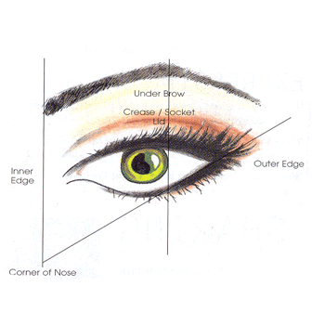

Recital Tickets

Recital Tickets ONLINE
Saturday, May 11th Sales Open at Noon
Sales close June 1

Click on link to Purchase BDC recital tickets:

Purchase Tickets HERE

How much are recital tickets, is there a limit to how many I may purchase?

Tickets will be $25 per person ages 4 and older, 3 and under may sit on parents’ laps. VIP tickets (closest to stage) will be $30 per person. There are no limits to how many tickets a family may purchase.

All seats are assigned leaving you worry free the day of the recital.

How do I purchase recital tickets?

You may only purchase tickets ONLINE (see above link). Tickets go on sale on Saturday, May 11th at noon. I highly recommend you buy that day. You will be able to pick your seats. All seats are assigned.

What is VIP ticketing?

VIP tickets are the best seats in the auditorium. Main floor center.

What if I lose my tickets?

We will have a record of your ticket purchase and can check you in if you forget or lose your tickets.

Recital DVD & Thumb Drive

Lockwood Video will be recording our shows this year. ALL families will receive a downloadable link for both recitals. Your link will arrive approx. 2 weeks after recital to you via the email we have on file in your parent portal. You may share this link with anyone you want.

Each family will be charged a $35 fee charged to your May account for this downloadable link to both recitals. You will receive links to both shows even if your dancer is only in one show. If you would like to add a thumb drive for $20 that may be ordered separately
Click here to order a thumb drive
Recital Requirements
This is your complete list of what your dancer MUST wear for
DRESS REHEARSAL and RECITAL.

All dance shoes are available at Barres' N 'Blades. Links have been provided for tennis shoes. The links provided are a base for what we would like. They do not have to be the exact shoes. They are just an idea. Please make sure tennis shoes are solid colors.
*For classes with natural hair, dancers may wear hair half up half down, in a ponytail, all down, etc. Whatever is natural and comfortable for them.

Please make sure you know the song name of your dancer’s class as this will be what is listed in the recital lineup, dress rehearsal lineup and picture day lineup.
Click here to view your dancer’s recital costume

Monday
Class | Teacher | Song Name | Hair | Shoes | Tights | Accessories
Ballet/Jazz (Ballet Dance) | Miss Lizz | Rapunzel | Slicked back, low bun | Pink ballet shoes | Capezio pink footed tights | Flower headpiece, Right side of head near bun
Ballet/Jazz (Jazz Dance) | Miss Lizz | Get Your Sparkle On | Slicked back, low bun | Capezio tan jazz shoes | Capezio Caramel footed tights | Head Bow above bun. Fringe skirt, buckle pinned to waist of leotard. Arm band elastic loop on middle finger
Ballet/Lyrical (Ballet Dance) | Miss Lizz | Spanish Rose | Slicked back, low bun | Capezio split sole, pink canvas ballet shoes | Capezio ballet pink tights | Flower headpiece, right side of head. Pin skirt to leotard
Ballet/Lyrical (Lyrical Dance) | Miss Lizz | Live Your Story | Slicked back, low bun | Capezio tan canvas turners | Capezio stirrup caramel tights | Tan leotard strap on right shoulder. Black overlay on left side, skirt opening on left leg. Ribbon around the bun, ends hang below bun Static spray skirt
Ballet/Tap/Tumble (Boys) | Miss Kaylee | Rhythm |  | Black tap shoes | None | Hat
Ballet/Tap/Tumble (Girls) | Miss Kaylee | Rhythm | Slicked back, low bun | Black tap shoes | Capezio  Black tights | Hat on left side of head
Hip Hop ages 6-9 | Miss Portia | Racecar | Slicked back, low bun | Black tennis shoes with white soles | Capezio  Caramel tights | Tube socks, checkered scrunchie, checkered flags
Jazz ages 7-9 | Miss Lizz | Go Go Go | Slicked back, low bun | Capezio canvas tan jazz shoes | Capezio Caramel footed tights | No headpiece
Jr Elite Ballet | Miss Beth | The Good Fairies | Comp hair | Pink ballet shoes | Capezio  Pink tights | Headpiece on right side of head next to the bun
Junior Ballet | Miss Beth | The Good Fairies | Comp hair | Pink ballet shoes | Capezio  Pink Tights | Headpiece on right side of head next to the bun

Tuesday
Class | Teacher | Song Name | Hair | Shoes | Tights | Accessories
Ballet IV | Miss Beth | The Good Fairies | Comp hair | Pink ballet shoes | Capezio Pink footed tights | Headpiece on right side of head next to the bun
Ballet V | Miss Beth | The Good Fairies | Comp hair | Pointe shoes | Capezio Pink footed tights | Headpiece on right side of head next to the bun
Ballet/Tap (Ballet Dance) | Miss Katie | I See the Light | Slicked back, low bun | Pink ballet shoes | Capezio footed Pink tights | Purple bow in hair (place center above the bun)
Ballet/Tap (Tap Dance) | Miss Katie | Hot, Hot, Hot | Slicked back, low bun | Black tap shoes | Capezio Caramel  tights
Broadway Babies | Miss Michelle | "A" You're Adorable | Natural hair | Pink canvas/leather ballet shoes | Pink Capezio footed tights
INT Acro | Miss Kaylee | Gotta Have It | Slicked back, low bun | None | Capezio Caramel stirrup tights
Mini Ballet | Miss Beth | The Good Fairies | Comp hair | Pink ballet shoes | Capezio Pink tights | Headpiece on right side of head next to the bun
Mini Tap | Miss Linda | Almost There | Comp hair | Black tie up tap shoes | CapezioCaramel footed tights | Headband
Petite Tap (Boys) | Miss Linda | Sea Cruise |  | Black tap shoes | None
Petite Tap (Girls) | Miss Linda | Sea Cruise | Same hair as 'We Like to Party' | Black tap shoes | CapezioCaramel footed tights | Sequin bow headband
Senior Tap | Miss Linda | Rhythm Works | Comp hair | Black tap shoes | Caramel tights if you would like, red stirrup socks (came with costume) | Bandana as headband
Tap 10+ | Miss Linda | Feels So Good | Slicked back, low bun | Black tie up tap shoes | CapezioCaramel footed tights

Wednesday
Class | Teacher | Song Name | Hair | Shoes | Tights | Accessories
Ballet/Jazz (Ballet Dance) girls | Miss Michelle | Do You Want to Build a Snowman? | Slicked back, low bun | Pink canvas ballet shoes | Pink Capezio footed tights | Flower headpiece
Ballet/Jazz (Ballet Dance) boys | Miss Michelle | Do You Want to Build a Snowman? | Slick back | Black ballet shoes | Black socks
Ballet/Jazz (Jazz Dance) girls | Miss Michelle | Dance Through the Day | Slicked back, low bun | Tan canvas jazz shoes | Capezio  Caramel footed tights | Bow headpiece
Ballet/Jazz (Jazz Dance) boys | Miss Michelle | Dance Through the Day | Slick back | Black canvas or leather jazz shoes | Black Socks
Jr Elite Hip Hop | Miss Portia | Cruella | Comp hair | Supernanny shoes | None | Individual character extras
Jr Elite Tap | Miss Linda | Faith | Comp hair | Black tie up tap shoes | Capezio  Caramel footed tights | No headpiece
Junior Hip Hop | Miss Portia | Barbiez | Comp hair | Supernanny shoes | None | Scrunchie around bun
Junior Tap | Miss Linda | 9 to 5 | Comp hair | Black tie up tap shoes | Capezio Caramel footed tights | Headpiece
Mini Elite Ballet | Miss Beth | The Good Fairies | Comp hair | Pink ballet shoes | Capezio  Pink Tights | Headpiece on right side of head next to the bun
Mini Elite Hip Hop | Miss Portia | Charlie and the Hip Hop Factory | Comp hair | All black tennis shoes with white soles | None | Individual character extras
Teen Tap | Miss Linda | Are You With Me | Comp hair | Black tie up tap shoes | Black fishnets with caramel footed tights underneath | Headpiece on right side of head next to the bun
Tiny Tot Hip Hop (Boys) | Miss Jill | Watch Me Work | Slick back | All black tennis shoes with black soles | None
Tiny Tot Hip Hop (Girls) | Miss Jill | Watch Me Work | Slicked back, low bun | All black tennis shoes with black soles | Capezio  Caramel footed tights

Thursday
Class | Teacher | Song Name | Hair | Shoes | Tights | Accessories
Acro ages 6-9  (6:00 class) | Miss Kaylee | Strut | Slicked back, low bun | None | Capezio Caramel stirrup tights | Pony tail piece around bun
Acro ages 6-9  (6:45 class) | Miss Kaylee | That Dance That You Do | Slicked back, low bun | None | Capezio Caramel stirrup tights
Ballet 10+ | Miss Lizz | Night Sky | Slicked back, low bun | Capezio canvas split sole ballet shoes | Capezio ballet pink footed tights | Barret above bun
Hip Hop ages 6-9 (Girls) | Miss Portia | Men In Black | Slicked back, low bun | Black tennis shoes with white soles | CapezioCarmel tights | Sunglasses
Hip Hop ages 6-9 (Boys) | Miss Portia | Men In Black | Natural hair | Black tennis shoes with white soles | None | Sunglasses
Hip Hop 10+ (Girls) | Miss Portia | Jump | Slicked back, low bun | White tennis shoes | None | Gloves, hair scrunchy
Hip Hop 10+ (Boys) | Miss Portia | Jump | Natural hair | Black tennis shoes with white soles | None
Jazz ages 7-9 (Girls) | Miss Lizz | Footloose | Slicked back, low bun | Capezio canvas tan jazz shoes | Capezio caramel footed tights | Headpiece around bun, or rhinestone square pinned above bun.
Jazz ages 7-9 (Boys) | Miss Lizz | Footloose | Hair slicked back, so not in face | Black jazz shoes | Thin black dress socks | Silver tie pinned to shirt. Stretchy belt if needed on pants
Jazz 10+ | Miss Kaylee | Danza Kuduro | Slicked back, low bun | Tan canvas jazz shoes | CapezioCaramel footed tights | Headpiece on right side of head next to the bun
Lyrical 10+ | Miss Lizz | Rescue | Slicked back, low bun | Capezio canvas tan turners | Capezio Caramel stirrup tights | Pin lace to right side of the head
Mini Hip Hop | Miss Portia | Wild, Wild West | Comp hair | Black tennis shoes with white soles | CapezioCaramel tights | Cowgirl hat, horse riding stick OR Can-Can Skirt
Tap ages 7-9 (Girls) | Miss Lizz | Car Wash | Slicked back, low bun | Black lace up tap shoes | Capezio Caramel footed tights | No headpiece
Tap ages 7-9 (Boys) | Miss Lizz | Car Wash | Hair slicked back, so not in face | Black lace up tap shoes | Thin dress socks with tap shoes | White tank under shirt, if need to, sequins were itchy. Stretchy belt if needed on pants
Tiny Tot Hip Hop | Miss Portia | Nursery Rhymin' | Slicked back, low bun | Black tennis shoes with white soles | CapezioCaramel footed tights | Dollar sign chain necklace
Tiny Tumblers (Girls) | Miss Kaylee | All I Want to Do Is Dance | Slicked back, low bun | None | CapezioCaramel stirrup tights | Headpiece on right side of head next to the bun
Tiny Tumblers (Boys) | Miss Kaylee | All I Want to Do Is Dance |  | None | None

Friday
Class | Teacher | Song Name | Hair | Shoes | Tights | Accessories
Ballet/Lyrical (Ballet Dance) | Miss Kaylee | Starlight | Slicked back, low bun | Pink canvas ballet shoes | Capezio  Pink footed tights
Ballet/Lyrical (Lyrical Dance) | Miss Kaylee | Invisible | Slicked back, low bun | Tan canvas turners | Capezio Caramel  stirrup tights
Broadway Babies | Miss Kaylee | Butterfly | Natural hair | Pink canvas/leather ballet shoes | Capezio  Pink footed tights
Hip Hop ages 6-9 | Miss Kaylee | Feeling Golden | Slicked back, low bun | Black tennis shoes with white soles | Capezio  Caramel footed tights | No hat
Mini Elite Tap | Miss Linda | Hard Knock Life | Comp hair | Black tie up tap shoes | Capezio  Carmel footed tights | Headscarf tied under chin

Dance Recital Pictures
Friday, May 17th 4:00-8:00PM & Saturday, May 18th 10:00AM-2:00PM Individual Recital Costume Pictures at BDC

BDC will only be offering time slots for individual pictures. We will not be taking any group pictures. To have your dancer photographed and become part of our photo composites we hang on the wall, simply click on the sign-up link and pick a time that works for you and your dancer. If you have multiple costumes, please make sure to sign up for 2 or more slots.

Pictures will be available for pick up at Lake Orion High School dress rehearsal Saturday, June 1st in the lobby.

SIGN UP HERE
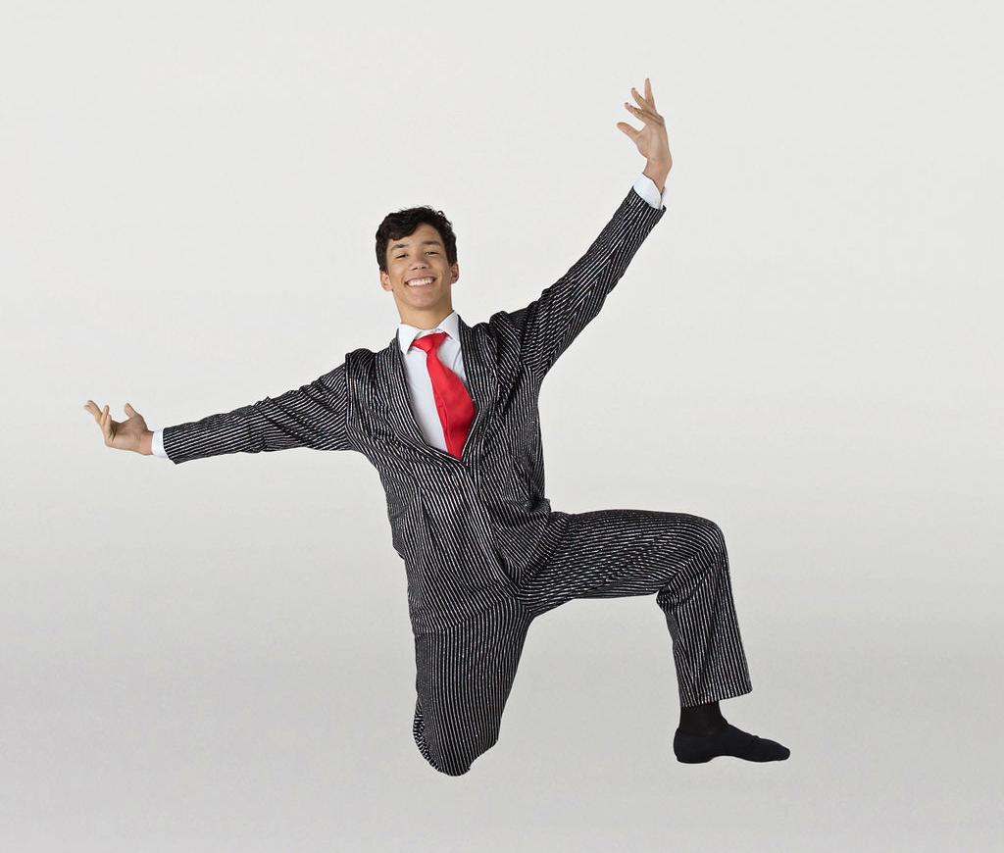

Recreational Picture Form (Print Option)
Recreational Picture Form (Digital Option)
Competition Picture Form

NO PARENTS will be allowed into the picture room. Photo boards will be provided for the dancer to pick out their pose.
Please have your dancer arrive at least 5 minutes before their assigned time. Please have their hair, makeup, and costume on.

Dress Rehearsal (not the same order as recital)
Saturday, June 1st at LOHS
Please arrive 20 minutes before your stage time
# | Dance | Time
 | Dad Dance Picture on Stage | 9:30-10:00
1 | Dad Dance | 10:00-10:30
2 | Watch Me Work | 10:30-10:40
3 | "A" You're Adorable | 10:40-10:50
4 | All I Want To Do Is Dance | 10:50-11:00
5 | I See the Light | 11:00-11:10
6 | Rhythm | 11:10-11:20
7 | Butterfly | 11:20-11:30
8 | Nursery Rhymin' | 11:30-11:40
9 | Do You Want to Build a Snowman? | 11:40-11:50
10 | Hot, Hot, Hot | 11:50-12:00
11 | Racecar | 12:00-12:10
12 | Spanish Rose | 12:10-12:20
13 | Dance Through the Day | 12:20-12:30
14 | Starlight | 12:30-12:40
15 | Live Your Story | 12:40-12:50
16 | Rapunzel | 12:50-1:00
17 | Invisible | 1:00-1:10
18 | Footloose | 1:10-1:20
19 | Get Your Sparkle On | 1:20-1:30
20 | Night Sky | 1:30-1:40
21 | Sea Cruise | 1:40-1:50
22 | That Dance That You Do | 1:50-2:00
23 | Car Wash | 2:00-2:10
24 | Rescue | 2:10-2:20
25 | Feeling Golden | 2:20-2:30
26 | Men In Black | 2:30-2:40
27 | Strut | 2:40-2:50
28 | Jump | 2:50-3:00
29 | Adult Hip Hop | 3:00-3:10
30 | Go Go Go | 3:10-3:20
31 | Hard Knock Life | 3:20-3:25
32 | Feels So Good | 3:25-3:35
33 | Almost There | 3:35-3:40
34 | Barbiez | 3:40-3:45
35 | Adult Tap (INT/ADV) | 3:45-3:55
36 | Danza Kuduro | 3:55-4:05
37 | Rhythm Works | 4:05-4:10
38 | Are You With Me | 4:10-4:15
39 | Gotta Have It | 4:15-4:25
40 | Cruella | 4:25-4:30
41 | Wild, Wild West | 4:30-4:35
42 | Charlie and the Hip Hop Factory | 4:35-4:40
43 | 9 to 5 | 4:40-4:45
44 | Faith | 4:45-4:50
45 | Adult Tap (Beg) | 4:50-5:00
46 | The Good Fairies | 5:00-5:30

Show 1
Sunday, June 2nd 11:00AM-2:00PM
*Bolded dance indicates costume
# | Class | Day | Song Name
1 | Dad Dance
2 | Broadway Babies | Tuesday | "A" You're Adorable
3 | Jazz 10+ | Thursday | Danza Kuduro
4 | Man's World
5 | It Is What It Is
6 | Mini Hip Hop | Thursday | Wild, Wild West
7 | Don't Stop Me Now
8 | Tiny Tot Hip Hop | Thursday | Nursery Rhymin'
9 | Ballet/Jazz | Wednesday | Dance Through the Day
10 | Here Right Now
11 | Never Love Again
12 | Junior Hip Hop | Wednesday | Barbiez
13 | Little Light
14 | I Am the Best
15 | Ballet/Tap/Tumble | Monday | Rhythm
16 | Hip Hop 10+ | Thursday | Jump
17 | Jr Elite Tap | Wednesday | Faith
18 | Stay
19 | Ballet/Tap | Tuesday | I See the Light
20 | We Like to Party
21 | Lyrical 10+ | Thursday | Rescue
22 | Adult Hip Hop | Tuesday
23 | Welcome to the Eras Tour
15 Minute Intermission
24 | Mini, Mini Elite, Junior, Jr Elite, Teen, Senior Ballet |  | The Good Fairies
25 | Hip Hop ages 6-9 | Monday | Racecar
26 | Tap 10+ | Tuesday | Feels So Good
27 | Tiny Tot Hip Hop | Wednesday | Watch Me Work
28 | Adult Tap | Wednesday
29 | Super Nanny
30 | The Reckoning
31 | Ballet 10+ | Thursday | Night Sky
32 | Petite Tap | Tuesday | Sea Cruise
33 | Ay Caramba
34 | Ballet/Tap | Tuesday | Hot, Hot, Hot
35 | Quiet Uptown
36 | Tiny Tumblers | Thursday | All I Want to Do Is Dance
37 | Mini Elite Tap | Friday | Hard Knock Life
38 | New York New York
39 | No Cover
40 | Lola
41 | Ballet/Jazz | Wednesday | Do You Want to Build a Snowman?
42 | Adult Tap | Tuesday
43 | INT Acro | Tuesday | Gotta Have It
44 | Frenchie
Teacher Presentation/Finale/Senior Goodbyes

Show 2
Sunday, June 2nd 4:00PM-7:00PM
*Bolded dance indicates costume
# | Class | Day | Song Name
1 | Dad Dance
2 | Broadway Babies | Friday | Butterfly
3 | Ballet/Jazz | Monday | Get Your Sparkle On
4 | Total Eclipse of the Heart
5 | Teen Tap | Wednesday | Are You With Me
6 | Mon Amour
7 | Junior Tap | Wednesday | 9 to 5
8 | 6:45 Acro | Thursday | That Dance That You Do
9 | The Adorables
10 | Role Model
11 | Can't Get You Out Of My Head
12 | Welcome to Wonderland
13 | Ballet/Lyrical | Monday | Spanish Rose
14 | Hip Hop ages 6-9 | Friday | Feeling Golden
15 | I'll Stand By You
16 | Cry To Me
17 | Moulin Rouge
18 | Tap II | Thursday | Car Wash
19 | Ballet/Lyrical | Friday | Starlight
20 | Adult Hip Hop | Tuesday
21 | Welcome to the Eras Tour
15 Minute Intermission
22 | Mini, Mini Elite, Junior, Jr Elite, Teen, Senior Ballet |  | The Good Fairies
23 | Adult Tap | Wednesday
24 | Ballet/Lyrical | Monday | Live Your Story
25 | Jazz II | Thursday | Footloose
26 | Sway
27 | Jr Elite Hip Hop | Wednesday | Cruella
28 | Mini Tap | Tuesday | Almost There
29 | Mini Elite Hip Hop | Thursday | Charlie and the Hip Hop Factory
30 | M3GAN
31 | Jazz II | Monday | Go Go Go
32 | Ballet/Jazz | Monday | Rapunzel
33 | I Feel Pretty
34 | I Lived
35 | Senior Tap | Tuesday | Rhythm Works
36 | Ballet/Lyrical | Friday | Invisible
37 | Call Me
38 | Through the Eyes of a Child
39 | Adult Tap | Tuesday
40 | Hip Hop ages 6-9 | Thursday | Men In Black
41 | 6:00 Acro | Thursday | Strut
42 | Frenchie
Teacher Presentation/Finale/Senior Goodbyes

Recital T-Shirts
Deadline to order recital t-shirts is May 18th
Order HERE link live May 11th

Recital t-shirts are available for purchase ONLINE. Recital t-shirts are a cotton, unisex, crew cut t-shirt. On the front will be our 12th annual recital logo. On the back will be the list of every dancer & parent who performs in our recital. Dancer’s name will be printed as it is listed in your parent portal. If you wish to check the spelling of your dancer’s name, please see the front desk no later than May 18th.

Recital T-shirts are $20, payable ONLY online when you purchase your recital tickets. Pre ordered T-shirts will be distributed to your dancer during Dress Rehearsal.

Flower Grams
Deadline to order Flower Grams is May 18th
Order HERE, link live May 11th

Do you ever wonder what your dancer is doing backstage while you are in the audience watching the recital? Do you wish you could go to the back and give them a hug and words of encouragement, well now you can almost…. LOL. This year we will offer flower grams for $3. A carnation will be delivered to your dancer with a note attached with a special message from you.

Flowers or Candy Bouquet
Deadline to order Flowers or Candy Bouquet is May 18th
^{Order HERE, link live May 11th}

BDC offers the option to families to preorder flowers or candy bouquets to celebrate your dancer’s big day. We will NOT be selling flowers or candy bouquets on the day of the recital. Take the stress off yourself and let us do the work.

Flower bouquets come in 3 roses or 6 roses, with baby breath, wrapped in tissue paper and cellophane.

Candy bouquets are a huge hit! We offer them peanut free or with peanuts. The bouquets look just like a bouquet of flowers, but on the end of the stems there will be candy. Full candy bars, gummy candies, and rice crispy are just some of the goodies your dancer will delight in.

BDC’s 12th annual recital will OPEN with a fantastic dance performed by our very own dads and dancers
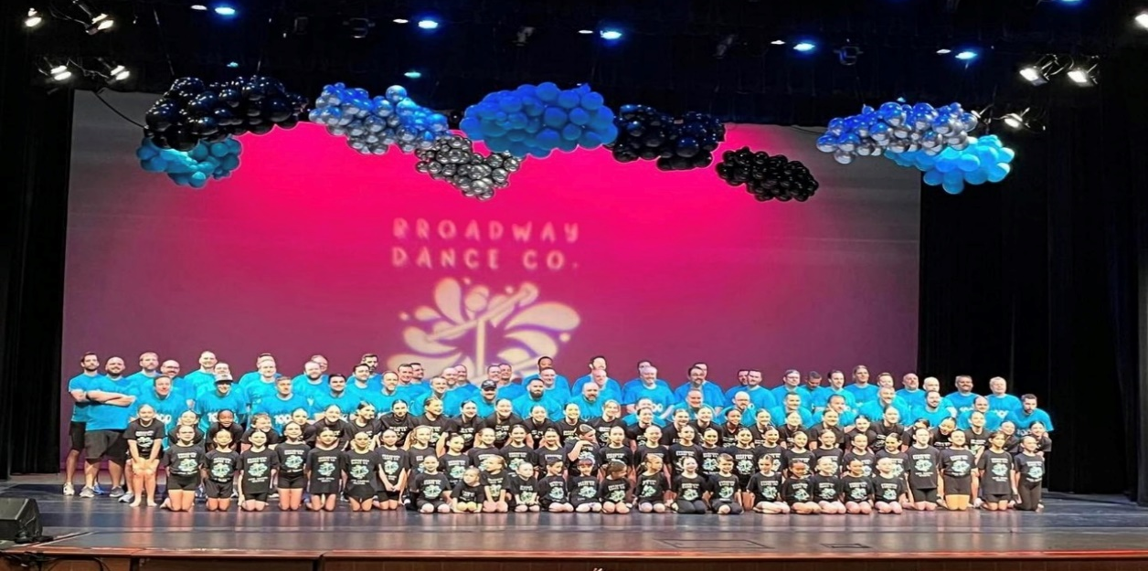

Don’t miss this opportunity to share a special moment on stage with your favorite dancer. Choreography will be simple and fun.

Place: BDC
Time: 6:30-8:00PM
Date: Friday, May 10, 17, & 31
Dress Rehearsal: June 1st 9:30-10:30AM
You MUST attend all rehearsals and Dress Rehearsal.

Cost will be $55 per couple (Dad & Dancer), $15 extra per additional sibling. Payable by cash, check or credit card. Price includes T-shirt for dad and recital T-shirt for 1 dancer. Shirts will be available at the last rehearsal.

Dads (Uncles, Grandpas, or other family member) will ONLY need to participate in the show their dancer is dancing in. If your dancer is in BOTH shows dads will dance in both shows.

Dad/Dancer Participation Form
Yes, I would like to join the Dad (Uncles, Grandpas, etc. too)/Dancer dance. I understand I need to attend all rehearsals.

Rehearsal dates are:
Friday, May 10, 17, & 31 6:30-8:00PM

Dress rehearsal is:
Saturday, June 1st 9:30-10:30am

Please complete the form below and return to BDC no later than May 10th.

1.
Dad’s Name (please print, it will be listed in recital program)

Dad T-shirt- (Circle size needed):

Small Medium Large X-Large 2XL

2.
Dancer’s Name

Kid T-Shirt (Circle size):

Small (4-6) Medium (8-10) Large (12-14)

Adult Small Adult Medium Adult Large

3.
Additional Dancer (s)-list T-Shirt size needed

Happy Ad Form
Ads for purchase at front desk before May 3rd

Happy Ads are available for purchase at the FRONT DESK ONLY. Each message will be displayed in our beautiful recital program. These are fun, positive sayings you create about your dancer that we print into our program. This creates a fun keepsake as well as positive encouragement on their big performance day!

Example:
Emma, we love you so much! Shine bright on stage! Mommy Daddy & Ella are cheering for you!

Dancer’s name__________________________________

Date submitted__________________________________

Happy Ad message $5:

________________________________________________

Cash, Checks or Credit Card Accepted

Business Advertisement
Ads for purchse at front desk before May 3rd

Do you own a business and would like to advertise in our recital program? Over 1,000 programs will be distributed to our audience. What a great opportunity to promote your business and gain new clientele.

Business card size- $25
¼ page with 1 pictures-$50
½ page ad-$75

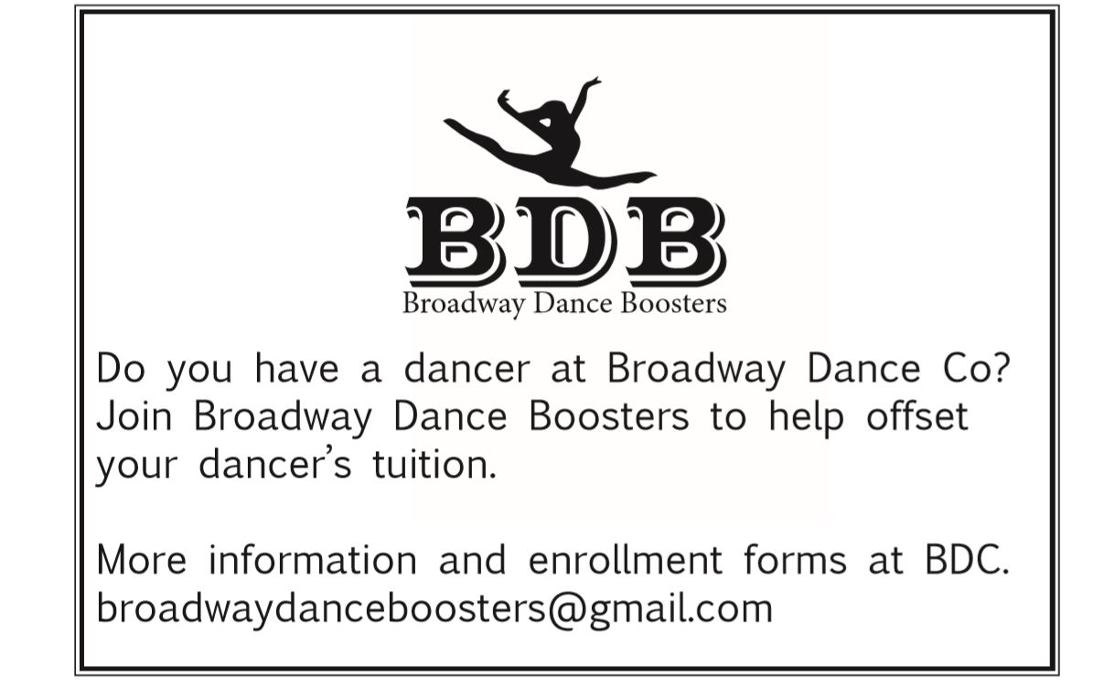

Yes, I would like to advertise my business in the recital program ________

Please select what size ad you would like

Business Card Size Ad ______ ¼ Page Ad _______ ½ Page Ad________
Payment Method (for BDC staff)

Cash__________ Check_________ Credit Card________
Parent Volunteer Form
*Accepting forms now until May 18th
In order to help our shows run smoothly, we need Female parent volunteers to help supervise dancers waiting in the back.
All dancers ages 4 & older are required to stay in the dressing rooms with their class during the entire recital.
Dancers are securely checked in and monitored by staff and parent volunteers throughout the entire performance. No child can leave or be checked out early. Riley monitors the check in and out process.
Parent volunteers are needed to escort dancers to the stage before and after they perform. Parent volunteers are responsible for helping change dancers, take them to the bathroom and are required to stay will their assigned class until the LAST DANCER HAS BEEN CHECKED OUT.
If you volunteer, you will be able to watch your child dance from backstage. You also will be given one free recital ticket to the show of your choice. A free ticket code will be emailed to you prior to tickets sales to use at check out.
I understand that I must be present backstage with my dancers’ class from the beginning of the show until the last dancers are picked up after the show. I understand that I am responsible for both my child, my child’s class, and possibly other classes backstage. I understand some of my duties while volunteering will be to help change shoes, tights, or costumes. I may need to assist a dancer to the bathroom.
Only 2 parent volunteers needed for recreational classes ages 9 & under.
I agree to the above statement.

__________________________ _______________________
Printed Name Signature

__________________________ _______________________
Child’s class name Class day and time

Important Dates
To receive a recital text remind please type @updatebdc to 81010.

May 3rd-Deadline for Happy Ads & Business Ads

May 10th- Dad Dance forms due

May 10th-First Dad Dance rehearsal at studio 6:30-8:00PM

May 11th- Recital Tickets, Recital T-Shirts, Flower & Candy Bouquets go on sale ONLINE at noon

May 17th-Second Dad Dance rehearsal at studio 6:30-8:00PM

May 17th- Recital Pictures at studio 4:00PM-8:00PM

May 18th- Recital Pictures at studio 10:00AM-2:00PM

May 18th- Final day to order T-Shirt, Flower Grams, Flower Bouquets, Candy Bouquets, ONLINE, Parent Volunteer forms due

May 31st-Last Dad Dance Rehearsal at studio 6:30-8:00PM

June 1st-Dress Rehearsal, see lineup on page 15

June 1st-Recital ticket sales close

June 2nd-Show 1 11:00AM-2:00PM, see lineup on page 17

June 2nd-Show 2 4:00PM-7:00PM, see lineup on page 18

Reminders

Make sure your dancer has all necessary shoes, tights, hair pieces, etc. for dress rehearsal and recital.

Label all costume pieces, shoes, accessories, etc.

Only parent volunteers will be allowed backstage and in the dressing room during the show. No other parents will be allowed backstage.

Dancers will not be allowed to be signed out until the recital is over.

Fill out your picture order form prior to arriving to dress rehearsal and picture day.

Recital pictures may be purchased with cash or checks only.

You may not purchase recital tickets until your account balance is paid in full.

To receive a recital text remind please type @updatebdc to 81010.

