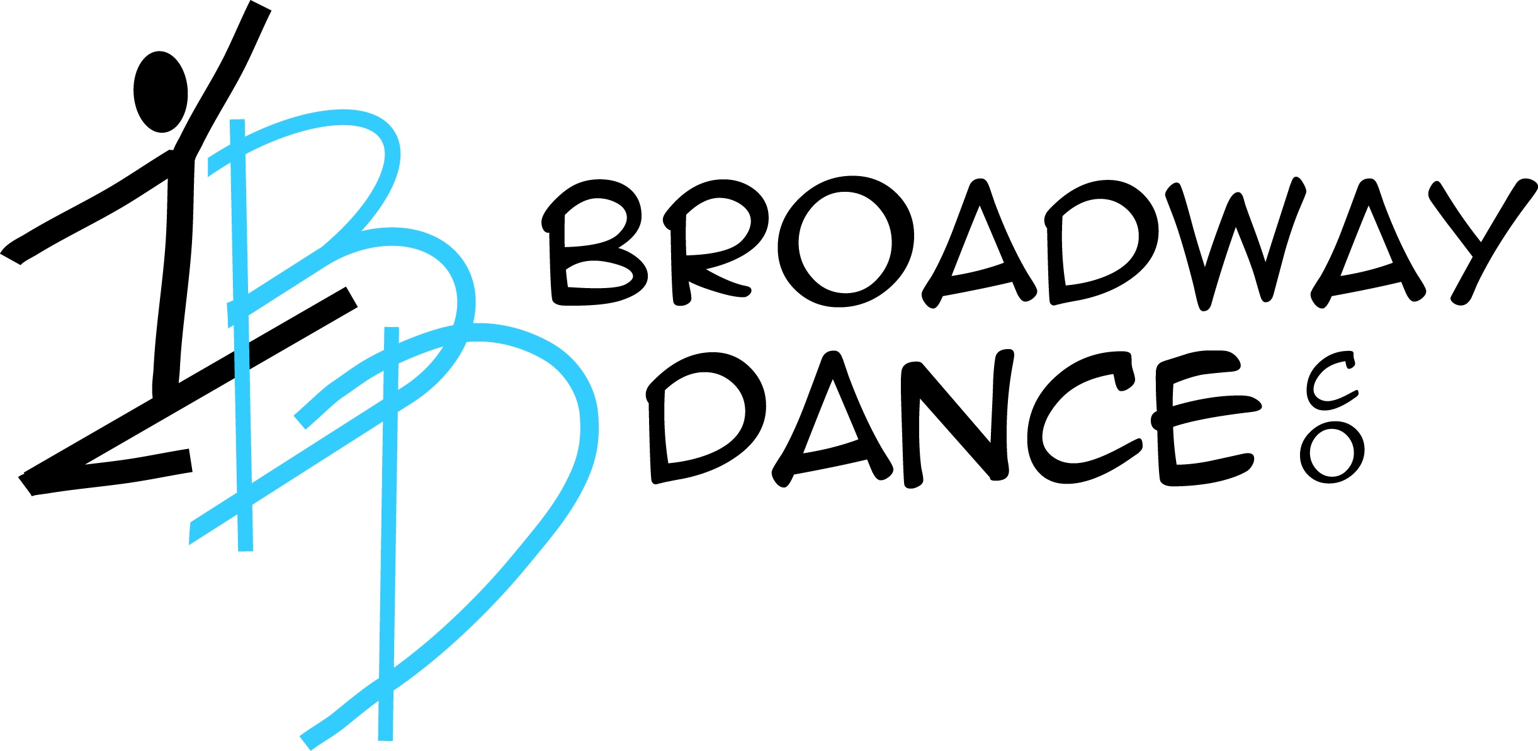

Studio Handbook 2019/2020

Broadway Dance Company Co. was created for the dancer who loves to dance and wants to grow technically in their art form. Our goal at BDC is to provide students, from beginners to advance, with the classes they deserve and continue to stand as a leader in dance training in the Lake Orion area.

Broadway Dance Co. offers dancers a full schedule of weekly classes, guest choreographers, and auditioning opportunities. All of our offerings embrace ballet, the foundation of dance, and incorporate our Broadway Dance Co. commitment to excellence.

Our Studio has friendly, college educated, professional instructors who will push a student to their potential and not give up on them and a community of parents who support their dancer in our nurturing and fun environment.

Thank you,
Michelle Larnard
Owner/Artistic Director
Life Is Not a Dress Rehearsal, so pick the BEST studio for your dancer the first time…..Broadway Dance Co.!

Welcome to Broadway Dance Co. (also referred as BDC) We are so excited to have you as part of our artistic community. Please read through the following pages with your dancer. We hope that your time at Broadway Dance Co. will surpass your expectations and that your dancer will thrive with BDC, Thank you for choosing us!

Our contact information is:
698 S Lapeer Road
Lake Orion MI 48362
248-693-2555
www.broadwaydanceco.com

A. BDC Dress Code:
Broadway Dance Co. believes that a student’s attire greatly determines the attitude she/he holds regarding work rehearsal and recital. Therefore we require that the standard of appropriate neatness and class-designated dress be observed at all times. General guidelines are a follows:

- Students dancewear should fit properly, it should not be too reveling or have any inappropriate message on it.
- Student’s underwear should not be visible beneath his/her dance clothes. I.E. no bras showing, low rider pants, etc.
- Hair should be pulled away from the face; mandatory bun/no bangs for all ballet classes.
- Mandatory black leotard, pink tights and split sole ballet shoes (leather or canvas) for all ballet classes.
- Dance attire for all other classes should be leotard, tights, booty shorts, or dance top and pants. Street clothes ONLY for Hip Hop Classes. No jeans!
- No jewelry may be worn in dance class, small stud earrings acceptable.
- Dance shoes should only be worn in dance class, they must be clean and debris free so as not to track dirt into the dance rooms.

B. BDC Studio Rules and Policies:

- Dancers will respect the studio by not eating in the dance rooms. Designated areas are made available.
- Dancers will arrive 10 minutes early to all classes, so they are prepared to start when class begins
- Dancers will not engage in any curse language or bring any inappropriate material to the studio.
- Anyone caught drinking alcohol or using any illegal drugs will be removed from the premises.
- Dancers are not permitted to leave the building and walk to local restaurants unless a signed permission slip has been turned into the front desk.
- Dancer will give all teachers respect during class, by not talking back, coming prepared, having hair secured away from my face and in the proper dance clothes.

C. Costumes:

Required class costumes will be $70 (child size), $80 (adult size)each. I understand that a $70/$80 per costume fee will be due November 1, 2019. Costumes will be used for our June recital 2020.

D. Payment Policies and Fees:
All payments are due in full by the 1st of the month. If my payments are late by 10 days I will be charged a $20 late fee. There will be a $25 returned check fee. If you choose to withdrawal your dancer for any reason, please submit a withdrawal form to the administrative office by the 15th of the month so that the withdrawal can be applied before the next tuition payment is due.

There will be no refunds for missed classes or missed privates. You are responsible for the tuition regardless of absences.

One Boy dances for free with a full tuition sibling.

Tuiton for September 2019-May 20
Hours per week Tuition Per month
30 mins $45
45 Min $55
1 Hour $60
1.50 Hours $70
2 Hours $75
2.50 $80
3.00 $85
3.50 $90
4.00 $95
4.50 $100
5.00 $105
5.50 $110
6.00 $115
6.50 $120
7.00 $125
7.50 $130
each add’t ½ hr add $5
Privates
30 Minutes: $40.00
1 Hour $80.00

1st dancer will pay full tuition
1st sibling will receive 20% discount
2nd sibling will receive 30% discount
$15 Registration, Fee $25 per family (non-refundable)

E. Closing/Cancellations:

BDC followings the Lake Orion school district holiday calendar. We sometimes follow their school closings due to inclement weather. There are no makeup classes for studio closure due to inclement weather. We will send texts message and emails if we are open or closed due to weather closings.

If a class is canceled, due to low enrollment, a full refund will be issued if we cannot find another class for that student.

F. Calendar of events:

I have been made aware of the calendar of events planned for the 2019/2020 year. I realize that some dates are subject to change but BDC will give advance notification if this occurs:

September 2019
9-Fall Classes begin

October
23-30 wear your Halloween costume to dance
31- CLOSED Halloween

November
27-30-CLOSED Thanksgiving

December
7-LO Lighted Holiday Parade
21-last day of classes

January 2020
6-all classes resume

February
17-18 CLOSED- Mid winter Break

March/April
30-5 CLOSED Spring Break

May
TBA Studio picture Day no classes
TBA Competition team auditions
28-CLOSED Memorial Day

June
5-last day of classes
6-Dress Rehearsal LOHS
7- Recital Lake Orion HS

G. Authorization for Use of Image or Likeness and Release Form

I hereby irrevocably grant to Broadway Dance Company, LLC, its employees, officers, directors, successors in interest, licensees, partners, assigns and agents (collectively the “Company”), the right to interview me and to take, use, reproduce, exhibit, display, broadcast, distribute, edit, alter and create derivative works of audio and visual materials of me (alone or with other persons) and my name, image, voice and likeness. I understand and agree that the Company owns the audio and visual materials and all rights related to them.
I hereby irrevocably permit and authorize the Company to use my name, image, voice and likeness for any lawful purpose and in any form whatsoever, including but not limited to use in the Company's events, activities, products, services, promotions, advertisements and marketing materials. I waive the right to inspect or approve any finished materials wherein my name, image, voice or likeness appears, and any right to royalties or other compensation arising or related to the use of such materials by the Company.
I hereby completely and unconditionally release the Company from any and all claims, demands and causes of action which, I, my heirs, representatives, executors, administrators or any other persons acting on behalf of my estate have or may have by reason of this authorization and release and the creation or use of materials wherein my name, image, voice or likeness appears.
If applicable, the undersigned Guardian acknowledges that he/she is the legal parent or guardian of the minor and is signing this document on behalf of the minor and that THE MINOR SHALL BE BOUND BY ALL THE TERMS OF THIS DOCUMENT. By signing this document without a parent or guardian’s signature, the undersigned represents that he/she is at least 18 years of age.
H. Participant Liability Waiver Polices:

As a participant or participant’s parent/legal guardian, I understand that participating in any dance class, workshop, rehearsal or performance, there is a possibility of physical injury. I, therefore agree to assume all risks of any such injury, which might occur during any class, rehearsal, or performance of Broadway Dance Company, LLC. I agree to waive any and all claims I may be arising out of, connected with or in anyway associated with the activities of Broadway Dance Company, LLC.

I do hereby fully release and discharge Broadway Dance Company, LLC its owners, employees, assistants and instructors from any and all claims from injuries, damages or loss which I or my minor child may have or which may occur as a result of participation of BDC’s activities.
I have read this document titled, Studio Handbook 2019/2020. I understand its contents and meaning, and freely agree to its terms and conditions.
PRINTED NAME:
DATE:

ADDRESS:

PHONE/E-MAIL:
SIGNATURE (if over 18 years of age):

SIGNATURE OF GUARDIAN (if under 18 years of age):

